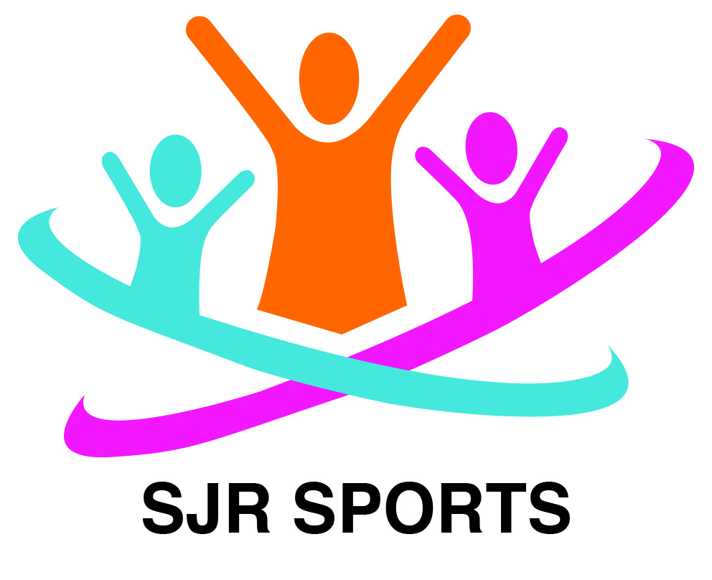

SJR Sports

Staff Behaviour Policy

SJR Sports expects all members of staff to follow our Staff Behaviour Policy, which sets clear guidance on the standards of behaviour required from our staff and volunteers. The guidance aims to encourage staff to meet the highest possible standards of conduct. Club staff are in a position of trust and influence as role models for the children in their care, and as such must demonstrate behaviour that sets a good example to all users of the setting.

Club staff also have a responsibility to maintain their reputation and the reputation of the Club, both during and outside of working hours.
Behaviour
Our staff team are ambassadors for SJR Sports and we expect them to conduct themselves professionally at all times. Staff should treat anyone attending the Club (children, parents/carers and visitors) courteously and with respect.
We expect staff to value all the children as individuals and to comply with the Club’s Equalities policy at all times.
Swearing and abusive behaviour are not tolerated from anyone at the Club. If any member of staff exhibits such behaviour they will be subject to the Club’s disciplinary procedures.
For more details see our Aggressive Behaviour policy and Staff Disciplinary policy.
Dress code
Whilst working at SJR Sports staff will need to help to set up and pack away the setting, prepare food, facilitate craft activities and engage in physical activities with the children. The clothing and footwear worn should be chosen accordingly, taking into account comfort, health and safety, and practicality. Revealing or excessively tight clothing is not acceptable.
Whilst on duty all staff should wear the approved Club sweatshirt / T shirt / colours / name badge at all times.
Confidentiality and social media
Staff must not pass on any information about children attending the Club, or their parents and families, to third parties without their permission. The only exception to this rule is information sharing with specific external agencies if there is a safeguarding issue. (‘Third parties’ includes other parents, friends, other children at the Club, the press, etc.)
Posting any material relating to the Club or its users on social media sites (unless expressly permitted by the Manager) is forbidden. Any staff who breach this rule will face disciplinary action.
See our Data Protection policy, Social Media policy, Safeguarding policy and Staff Disciplinary policy for more details.
Use of mobile phones and cameras
Staff personal mobile phones must kept on the person to be able to make contact between staff during working hours
If a member of staff needs to make an urgent personal call they can use the Club phone or make a personal call from their mobile in the staff room.
If a member of staff has a family emergency or similar and needs to keep their mobile phone to hand, they must obtain prior permission from the Manager or Deputy.
Staff may only use the club camera to take photographs of children at the Club, except with the express permission of the Manager.
Staff must never use their personal mobile phones or cameras to take photographs at the Club during working hours. Doing so will be considered gross misconduct and may result in instant dismissal.
See our Mobile Phone policy, Safeguarding policy and Staff Disciplinary policy for more details.
Smoking, alcohol and drugs
Staff are not permitted to smoke anywhere on the Club premises, including the outside play areas.
Staff are not permitted to bring alcohol or illegal drugs onto the Club premises. If a member of staff arrives at work under the influence of alcohol or drugs they will be asked to leave immediately and disciplinary action will be taken.
If a member of staff is taking prescription drugs which might affect their ability to function effectively, they must inform the Manager immediately.
Any prescribed medication needed by a staff member whilst at the Club, must be stored safely in the kitchen area out of reach and sight of the children attending the Club.
See our Smoking, Alcohol and Drugs policy for more details.

Gross misconduct
Staff will be dismissed without notice if they are found to have committed an act of gross misconduct. Examples of gross misconduct include, but are not restricted to:
- Child abuse
- Failing to comply with health and safety requirements
- Physical violence
- Ignoring a direct instruction given by the manager
- Persistent bullying, sexual or racial harassment
- Being unfit for work through alcohol or illegal drug use
- Theft, fraud or falsification of documents
- Being disqualified under the terms of the Statutory Framework for the Early Years Foundation Stage (Section 75 of the Childcare Act 2006) or the Children’s Act 1989.
The Manager will investigate the alleged incident thoroughly before any decision to dismiss is made. For full details see our Staff Disciplinary policy.

This policy was adopted by: SJR Sports | Date: September 2025
To be reviewed: September 2026 | Signed: Stephen Robertson

Written in accordance with the Statutory Framework for the Early Years Foundation Stage (2021): Safeguarding and Welfare Requirements: Child Protection [3.4-3.8], Suitable people [3.11, 3.13, 3.19] and Disqualification [3.14-3.16], Safety and suitability of premises, environment and equipment [3.55], Information and records [3.69]

