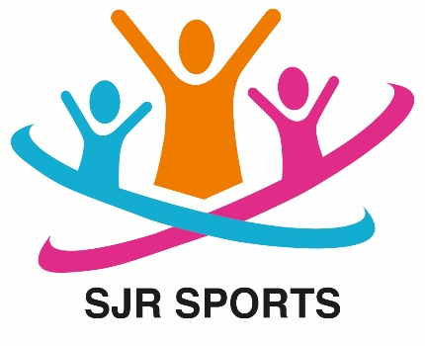

SJR Sports

Child Induction Policy
When children first join SJR Sports they will be allowed to settle in at their own pace.
We encourage parents or carers to visit the premises with their children shortly before they are due to start. This gives the children the opportunity to look around the Club and ask any questions. It also gives parents the opportunity to complete the necessary paperwork for registration with the Club if this has not yet been done.
If necessary, parents or carers may stay with their children during the first week to help them settle in.
Induction for new children
- The new child will be introduced to all members of staff and informed about any other regular visitors to the club.
- EYFS children and their parents will be introduced to their key workers.
- The Club’s activities, rules and routines, such as snacks, signing in and signing out, will be explained.
- The child will be shown around the Club and told where they can and cannot go.
- The fire evacuation procedure and the locations of all fire exits will be explained.
- The child will be introduced to the other children at the Club and allocated a ‘buddy’ who will assist them with finding their way around and involving them in activities.
- Staff will keep a close eye on the new child and will ensure that they are happy, engaged and feel secure in the Club environment.
If a child seems to be taking an unusually long time to settle in, this will be discussed with their parents or carers to see what can be done to make the transition easier.

This policy was adopted by: SJR Sports | Date: September 2025
To be reviewed: September 2026 | Signed: Stephen Robertson
Written in accordance with the Statutory Framework for the Early Years Foundation Stage (2021): Safeguarding and Welfare Requirements: Information and Records [3.71-3.72]; Safety and Suitability of Premises, Environment and Equipment [3.54} and Child Protection [3.7].

