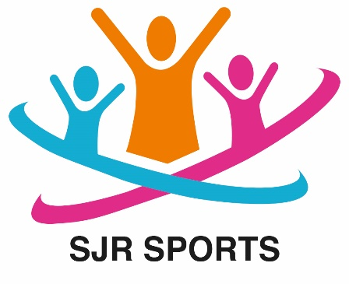

Out of School Club

Staff Induction and Development
Each new member of staff at SJR Sports receives a copy of all of the Club’s policies and procedures. Within the first month of their employment, the manager will discuss the practical implications of the Club’s policies and procedures with them. The new staff member will sign the Policy Confirmation Slip to confirm that they have read and understood the Club’s policies.
All new staff will receive induction training which will include:
- Introduction to their colleagues, children and parents or carers
- Tour of the premises including: identification of all fire exits, location of first aid kit and fire safety equipment, and information about the emergency evacuation procedures; outside play areas, fire assembly points, collection points at the school, route from the school to the Club etc, and identification of any known hazards
- Thorough briefing on our Safeguarding, Equalities and Data Protection policies and procedures.
- Location of Club records and documentation, storage, toilets etc
- Overview of all aspects of the day-to-day management and running of the Club
- Explanation of the Club’s obligation to comply with the Early Years Foundation Stage (EYFS)
- Explanation of the processes for appraisals, training and development, booking holidays, sickness absence, staffing rota, etc.

Development and training
To ensure that staff development needs are being met, and that staff training and qualifications are meeting the requirements of the Club and the EYFS, we provide all our staff with:
- a thorough induction process
- a system of regular appraisals and reviews
- opportunities for training and professional development.
We also keep an up to date record of staff qualifications and maintain a training development plan.

Appraisals and reviews
The manager will hold an annual appraisal meeting with individual staff. The appraisal will reflect on progress and challenges over the previous year and identify current knowledge and skills, areas for future development and potential training needs.
The manager will hold quarterly reviews with staff to monitor their professional development and their progress with regards to the targets set, and issues raised, during their annual appraisals.

Training
The manager will identify and promote suitable training courses for staff so that they can expand their professional development and keep their knowledge of childcare and playwork issues up to date. Staff are expected to attend training courses as and when requested by their manager.

Staff meetings
Staff meetings provide a forum in which staff can share information, solve problems and raise work issues. Staff meetings are held every as regular as possible, we aim to meet at the end of each working day.
This policy was adopted by: SJR Sports | Date: September 2025
To be reviewed: September 2026 | Signed: Stephen Robertson
Written in accordance with the Statutory Framework for the Early Years Foundation Stage (2021): Safeguarding and Welfare Requirements: Qualifications, training, support and skills [3.20 - 3.26].

